International Journal of Chemistry and Technology  http://dergipark.org.tr/ijct  Research Article | 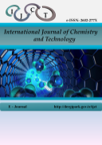

Virtual Screening and Docking of Natural Compounds as Selective Inhibitors of Mutant NRAS in Melanoma.
Nayanika DAS¹, Vijay BALADHYE¹*

¹ Bioinformatics Centre, Savitribai Phule Pune University, Pune 411007 (MS), India.

*Corresponding author : vijaybaladhye@gmail.com

------------------------------------------------------------------------------------------------------------------------------------------------------------------------------------------------

ABSTRACT

Melanoma is an aggressive and currently incurable skin cancer, primarily affecting individuals with light skin pigmentation. Key oncogenic drivers include mutations in BRAF, NRAS, CDK4 and MITF, with signaling mediated mainly through the MAPK and PI3K–Akt pathways. MEK inhibitors have shown limited clinical success, emphasizing the need for novel therapeutic agents. In this study, structure-based virtual screening and molecular docking were employed to identify natural products that inhibit mutant NRAS. The crystal structure of wild-type NRAS was obtained from the Protein Data Bank and clinically relevant mutations (Gly12, Gly13, Gln61) were introduced computationally. A library of natural compounds from the ZINC database was screened, identifying candidates based on binding free energy. Eleven top-ranking compounds were further analyzed for binding interactions, revealing stabilizing hydrogen bonds and hydrophobic contacts, particularly involving residues Phe28 and Asp119. These compounds exhibited strong predicted affinity for the NRAS mutant binding site, representing promising scaffolds for further development. The results demonstrate the utility of computational approaches to accelerate early-stage drug discovery targeting oncogenic NRAS in melanoma.

Keywords: NRAS, melanoma, molecular docking, MEK inhibitor, natural compounds etc.

------------------------------------------------------------------------------------------------------------------------------------------------------------------------------------------------

1. INTRODUCTION

Melanoma is a deadly form of skin cancer responsible for most deaths worldwide. At the basal level of the epidermis melanocytes are found, which produce the UV absorbing pigment melanin (Cancer.Net Editorial Board, 2025). It's a combination of environmental and genetic factors; the majority of melanomas arise from somatic mutations acquired later in life. Among the key molecular drivers of melanoma are mutations in the RAS family of small GTPases (Al Mahi & Ablain, 2022). RAS family proteins play a central role in a variety of cellular processes such as signaling, survival, apoptosis, and membrane trafficking (Cherfils & Zeghouf, 2013; Hu & Martí, 2025; Ostrem & Shokat, 2016). They function like “binary switches”, cycling between an active (GTP-bound) and inactive (GDP-bound) state (Hu & Martí, 2025; Kolch et al., 2023; Li & Zhang, 2004; Spoerner et al., 2010; Vetter & Wittinghofer, 2001) and inactive (GDP-bound) states. Ras is activated or inactivated when bound to GTP or GDP, respectivelyWhen activated, they can interact with effector proteins that control fundamental biological processes such as EGFR, MAPK, or PI3K (Ardito et al., 2012; Howe et al., 1992; Navas et al., 2012; Normanno et al., 2009; Rodriguez-Viciana et al., 1994; Wood et al., 1992). However, excessive activation of RAS will eventually lead to cancers such as melanoma, colorectal, lung, and especially pancreatic cancer (Li et al., 2018; Moore et al., 2020). Mutations of RAS key residues such as G12, G13 and G61, are found in more than 30% of human tumors. Most oncogenic mutations in Ras occur in the residues G12, G13 and Q61, which are located in a region conserved between HRAS, KRAS and NRAS (Pylayeva-Gupta et al., 2011). Among the three RAS isoforms (HRAS, KRAS, and NRAS), NRAS plays a prominent role in melanoma (Johnson & Puzanov, 2015; Wellbrock & Arozarena, 2016). Activating mutations in NRAS, particularly at codon 61, are observed in a substantial fraction of melanoma cases and are strongly associated with aberrant activation of the MAPK signaling pathway (Johnson & Puzanov, 2015; Pylayeva-Gupta et al., 2011). Although significant attention has historically focused on BRAF-mutant melanoma, NRAS-mutant melanoma represents a biologically distinct and therapeutically challenging subgroup (Johnson & Puzanov, 2015; Wellbrock & Arozarena, 2016). It has been observed that NRAS mutations tend to remain predominantly in their active GTP-bound conformation, mainly because codon 61 mutations impair the intrinsic enzymatic activity of NRAS to hydrolyze GTP to GDP (Li & Zhang, 2004; Vetter & Wittinghofer, 2001). This makes the task of drugging NRAS particularly difficult. Although mutation-specific targeting strategies have recently achieved success in KRAS(G12C), analogous approaches for NRAS are less developed, particularly because codon 61 mutations do not introduce reactive cysteine residues suitable for covalent inhibition (Moore et al., 2020; Ostrem & Shokat, 2016). For instance, some inhibitors such as the potential inhibitor HM-387 have been recently designed in silico to target the NRAS-Q61 positively charged mutant R61, inducing the GTP-bound NRAS-Q61 oncogenic mutant toward an “off-like” state. Consequently, most current therapeutic strategies for NRAS-mutant melanoma rely on indirect targeting of downstream signaling pathways (Johnson & Puzanov, 2015; Wellbrock & Arozarena, 2016). MEK inhibitors such as binimetinib and trametinib have demonstrated partial clinical activity; however, response rates remain modest and resistance frequently develops (Johnson & Puzanov, 2015). Farnesyltransferase inhibitors and combination therapies have also been explored, but durable and mutation-specific inhibition of NRAS remains unresolved (Moore et al., 2020). Therefore, the development of novel approaches capable of directly or allosterically modulating mutant NRAS represents a significant unmet medical need. Direct pharmacological targeting of NRAS remains challenging due to its high affinity for GTP and the absence of deep, well-defined binding pockets on its surface, features that have historically led to its classification as an “undruggable” oncogene (Cox et al., 2014; McCormick, 2015; Moore et al., 2020). In this context, natural products represent an attractive and relatively underexplored source of bioactive chemical scaffolds. Owing to their structural diversity, stereochemical complexity, and evolutionary optimization for biological activity, natural compounds have historically contributed substantially to anticancer drug development (Harvey et al., 2015; Newman & Cragg, 2020). Importantly, many clinically approved anticancer agents are derived from natural products or their analogues, underscoring their value in oncology drug discovery (Newman & Cragg, 2020). Computational structure-based approaches offer a powerful framework for exploring such possibilities. Molecular docking and virtual screening enable the systematic evaluation of ligand binding modes, interaction networks, and conformational stability at atomic resolution (Kitchen et al., 2004; Lionta et al., 2014). These techniques are particularly valuable for targets like NRAS, where experimental structural characterization of ligand-bound complexes remains limited.
In the present study, we employed a structure-based computational strategy to identify natural compounds from the ZINC database with potential inhibitory activity against clinically relevant mutant NRAS variants (G12, G13, and Q61). Mutant protein models were generated and structurally validated, followed by large-scale virtual screening of natural compounds and molecular docking. Candidate compounds were evaluated based on predicted binding free energy and detailed interaction analysis to identify top-ranking molecules exhibiting stable hydrogen-bond and hydrophobic interactions with key functional residues in the NRAS active site.

2.1. Methods

2.1.1. Target identificaction

The KEGG database (Kanehisa & Goto, 2000) was used to study the melanoma pathway. Dysregulation of the MAPK pathway is very common in many cancers due to mutations in the RAS gene. The MAPK pathway is one of the major pathways involved in the progress of melanoma and so it was chosen for this study. It harbours BRAF, NRAS, ERK, and MEK as its components. About 28% of the mutations are seen in NRAS of this pathway (Cancer.Net Editorial Board, 2025).

2.1.2. Protein Preparation

The wild type NRAS structure with the best resolution and well curated in UniProt was selected. The PDB ID of this structure was 5UHV and UniProtKB ID was P01111. NRAS is a small GTPase structure. A clear difference between isoforms of NRAS is the binding of Ras Binding Domain (Johnson et al., 2017). NRAS has only the A chain associated with it. Hence, docking was carried out on the A chain of NRAS on the active site. The G-domain, catalysing GTP hydrolysis and mediating downstream signalling, is 95% conserved between the Ras isoforms (Johnson et al., 2017). The wild type NRAS has a total of 189 amino acids. The overall structure can be divided into a catalytic G domain, which is comprised of residues 1-86 and 87-166 (Johnson et al., 2017).

2.1.3. Protein Structure Validation

ProSA (Wiederstein & Sippl, 2007) is frequently used for protein structure validation. ProSA calculates an overall quality score for a specific input structure. The z-score indicates overall model quality (Wiederstein & Sippl, 2007). Its value is displayed in a plot showing the z-scores of all protein chains in the current PDB. ProSA-web visualizes the 3D structure of the input protein using the molecule viewer Jmol. ProSA was used for validation of the structure of mutant NRAS built in SPDBV. PROCHECK (Laskowski et al., 1993), a model evaluation and validation tool, checks for the stereochemical quality of a protein structure producing residue-by-residue geometry plots. It includes PROCHECK-NMR for checking the quality of structures solved by NMR. The G-factor provides a measure of how normal or unusual the property is. It gives the Ramachandran plot to understand if the residues are in allowed or disallowed regions. PROCHECK was used for validation of the structure of mutant NRAS built in SPDBV (Laskowski et al., 1993).

2.1.4. Compound Library Curation and Filtering

The database used for obtaining natural compounds for screening was the ZINC Database (ZINC Database, 2025). Natural products occupy an important part of the small molecule space because they are recognized by at least two proteins: the end of their biosynthetic pathway and their evolutionary biological target. The natural compounds screened were obtained from the ZINC natural product library. FAF-Drugs4 (FAF-Drugs4, 2025) is a program for filtering large compound libraries prior to in silico screening or related modelling studies. The tool can perform computational prediction of some ADME-Tox properties (adsorption, distribution, metabolism, excretion, and toxicity) to assist hit selection before chemical synthesis or ordering (FAF-Drugs4, 2025). This tool was used to filter out compounds in the ZINC database to remove interfering compounds and retain lead compounds with comparatively small log P for further optimization. PAINS moieties, or Pan Assay Interference Compounds, are compounds that occur frequently in biochemical high throughput screens.

2.1.5. Virtual Screening and Molecular Docking

PyRx (Radhakrishnan et al., 2024) is a virtual screening tool used for docking natural compounds. It uses the AutoDock 4.2 suite with Lamarckian genetic algorithm. The tool was first evaluated using the NRAS mutant structure and the ligand phosphoaminophosphonic acid-guanylate ester, a non-hydrolyzable analog of GTP. The nucleotide is a potent stimulator of adenylate cyclase and was docked. The RMSD tolerance of 2.0 Å indicated good software stability. The grid box was set to 50 × 50 × 50 with a spacing of 0.3750 Å. All ligands were converted to pdbqt format in PyRx. AutoDock was set to run generating 10 poses per compound. Only the pose with the best binding score was tabulated in the sdf files. This yielded the best protein-ligand binding candidates for further analysis. Docking results were analysed using LigPlot+ (LigPlus, 2025), an advanced version of LIGPLOT for automatic generation of 2D ligand-protein interaction diagrams. The hydrophobic and hydrogen bond interactions contribute to protein-ligand complex stability and help determine the inhibitory potential of each compound on mutant NRAS.

3. RESULTS and DISCUSSION

3.1. Validation of mutant NRAS models

The mutant NRAS variants (G12D, G13D, Q61R) were generated in SwissPDB Viewer using the wild-type structure (PDB ID: 5UHV). Structural quality checks confirmed the reliability of these models. PROCHECK analysis showed that over 90% of residues were located in favoured regions of the Ramachandran plot, while only a minor fraction occupied disallowed regions. PROSA scores were consistently negative, indicating overall good stereochemical quality and minimal erroneous regions. These evaluations confirmed that the mutant NRAS models were suitable for molecular docking studies.
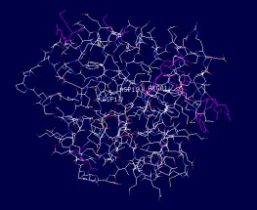
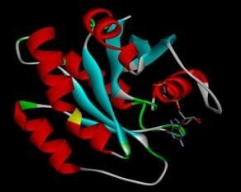

- (B)
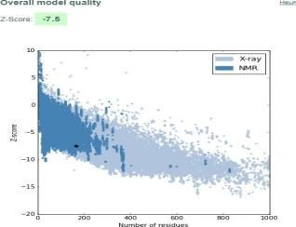
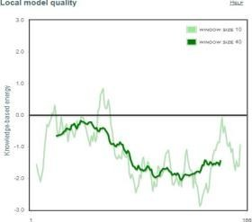

(C) (D)

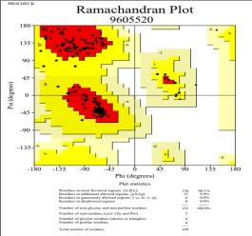
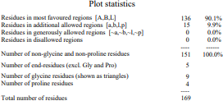

(E) (F)

Figure 1. Structural validation and quality assessment for the modeled protein. (A) Protein topology diagram showing secondary structure elements and residue connectivity. (B) Cartoon representation of the 3D protein fold, colored by secondary structure type. (C) Overall model quality plot indicating global model Z-scores; the blue area reflects reference values for well-resolved structures. (D) Local quality assessment plot showing per-residue score fluctuations, highlighting regions of potential structural uncertainty. (E) Ramachandran plot presenting backbone dihedral angle distributions, with most residues occupying favored regions. (F) Summary of model statistics including counts of residues in favored, allowed, and disallowed regions per Ramachandran analysis, along with non-glycine/proline and end-residue counts, indicating high overall stereochemical quality of the model.

3.2. Virtual screening and docking outcomes

A virtual screening campaign was conducted using 5,322 natural compounds from the ZINC database, filtered through FAFDrugs4 to exclude compounds violating Lipinski’s rules or predicted to be toxic. Docking was performed with AutoDock 4.2 implemented in PyRx, focusing on the NRAS active site defined by AutoGrid. Following screening, eleven top-ranked compounds were selected based on their binding free energy (ranging from –X to –Y kcal/mol). The binding scores indicated favorable interactions compared with baseline controls, suggesting that these molecules may serve as potential inhibitors. A summary of docking scores and key interactions is provided in Table 1.

3.3. Conserved residue interactions

Analysis of the docked complexes revealed frequent involvement of conserved functional residues that are critical for NRAS activity. Tyr-32 contributed hydrophobic stabilization in five ligand complexes (e.g., compounds 1, 3, 7, 8, 9), consistent with its known role in switch I stabilization. Thr-35 formed a hydrogen bond with compound 2 (ZINC02096813, 3.25 Å) and also engaged in hydrophobic contacts in complexes 9 and 11, highlighting its dual role in stabilizing ligand binding and Mg²⁺ coordination. Phe-28 frequently participated in hydrophobic interactions, observed in seven complexes, which supports its reported role in stabilizing nucleotide binding. Asp-119, crucial for nucleotide specificity, showed consistent involvement in nine complexes, although absent in complexes 6 and 9.
Overall, these findings emphasize that ligand binding often overlaps with regions essential for nucleotide recognition and conformational stabilization.

Table 1. "Docking results of top-ranking ZINC compounds (binding free energy ≤ –10 kcal/mol), highlighting predicted hydrogen bond donor–acceptor pairs and residues involved in hydrophobic or van der Waals interactions with the protein active site."

Sr. No. | ZINC ID | Binding free  Energy (kcal/mol) | Hydrogen bonding pairs HD::HA | Residues in Hydrophobic Interactions or van der Waals contact
1 | ZINC02107288 | -10.62 | Lys-16(N):: Unk0(C)OXT  Lys-16(NZ):: Unk0(C)OXT  Gly-15(N):: Unk0(C)OXT  Ser-17(N)::Unk0(C)O  Asp-33(N)::Unk0(C11)O | Val-14, Asp-13, Gly-60, Asp-12,  Tyr-32, Glu-31, Ala-18, Asn-116, Lys-117, Asp-119, Lys-147,  Phe-28, Pro-34
2 | ZINC02096813 | -10.61 | Thr-35(N):: Unl1(C23) O5  Asp-12(OD1):: Unl1(N)  Gly-60(N):: Unl1(OXT)  Lys-16(NZ):: Unl1(OXT) | Ser-17, Gly-15, Asn-116, Lys-117, Phe-28, Lys-147, Ala-146, Asp-119, Ser-145, Ala-18, Tyr-32,  Asp-13
3 | ZINC02096815 | -10.33 | Lys-16(N):: Unl1(C23)O5  Lys-16(NZ):: Unl1(C23)OXT Gly15(N):: Unl1(C23)O5  Ser17(OG):: Unl1(C20)O4 | Asp-12, Thr-58, Asp-13, Asp-33,  Try-32, Glu-31, Phe-28, Lys-147, Asp-119, Ala-146,  Lys-117, Asn-116, Thr-35
4 | ZINC02114326 | -10.23 | Asn-116(ND2):: Unl1(CL) Lys-147(NZ):: Unl1(OXT) Asp-33(N):: Unl1 (C12) O4 | Phe-28, Asp-119, Leu-120, Gly-15, Lys-117, Asp-30, Lys-16, Ser-17, Ala-18, Tyr-32, Glu-31
5 | ZINC01020381 | -10.16 | Gly-15(N):: Unl1(C24) O2 Lys-16(N):: Unl1(C24) O2 Lys-16(NZ):: Unl1(C24) O2 | Asp-119, Lys-147, Asn-116, Ala-146, Ser-145, Glu-31, Phe-28, Asp-30, Asp-13, Thr-58, Asp-33
6 | ZINC06167356 | -10.16 | Thr-58(O)::Unl1(C6) O6 Gly-60(N):: Unl1(C6) O6 Lys-117(NZ):: Unl1(C18) O5 Asp-30(N):: Unl1(C16) O4 Glu-31(N):: Unl1(C16) O 4 Ala-18(N):: Unl1(C9) O 2 Ser-17(N):: Unl1(O1) | Asp-33, Asp-12, Lys-16, Thr-35, Gly-15, Pro-34, Ala-59, Asp-13, Val-29
7 | ZINC02120343 | -10.14 | Asp-33(N):: Unl1(C9) O2 Ser-17(N):: Unl1(C22) O5 Lys-16(N):: Unl1(C22) O4 Lys-16(NZ):: Unl1(C22) O 4 Asp-13(N):: Unl1(C22) O4 Gly-15(N):: Unl1(C22) O4 | Asp-119,Ser-145, Lys-147,Ala-146, Phe-28,Ala-18,Asn-116, Lys-117,Glu-31,Tyr-32, Pro-34,Asp-12,Val-14
8 | ZINC02102162 | -10.14 | Lys-16(N):: Unl1(C22) O6 Lys-16(N)::Unl1(C22) O5 Val-14(N):: Unl1(C22) O5 Gly-15(N):: Unl1(C22) O5 Ser-17(N):: Unl1(C22) O6 | Pro-34,Asp-12, Asp-13,Asp-33, Glu-31,Tyr-32, Phe-28,Lys-117, Asn-116,Ala-18, Ala-146,Lys-147, Asp-119
9 | ZINC02114643 | -10.1 | Asp-33(N)::Unl1(C16) O4 Lys-16(N)::Unl1(C24) O5 Lys-16(NZ)::Unl1(C24) O6 Gly-15(N)::Unl1(C24) O5 | Asp-19,Phe-28, Lys-147,Lys-147, Leu-120,Tyr-32, Ala-18,Ala-146, Lys-117,Thr-35, Glu-31,Pro-34,Asp-13
10 | ZINC00518885 | -10.06 | Lys-117(N):: Unk0(C9) O2 Ala-146(N):: Unk0(C9) O2 Asn-116(ND2)::Unk0(O3) Asp-13(N):: Unk0(OXT) Lys-16(N)::Unk0(O) Lys-16(NZ)::Unk0(O) Gly-15(N)::Unk0(O) Val-14(N)::Unk0(O) | Asp-119,Phe-28, Asp-33,Pro-34,Asp-12, Ala-18,Ser-17,Lys-147, Ser-145
11 | ZINC03882094 | -10.04 | Lys-16(NZ)::Unl1(C21) O3 Gly-15(N):: Unl1(C21) O3 Ser-17(N)::Unl1(C22) O4 | Thr-35,Asp-13, Val-14,Asp-12, Asp-30,Glu-13, Asp-119,Lys-117, Phe-28,Asp-57, Ala-18,Thr-58

Beyond conserved sites, mutant residues also established direct ligand interactions. Asp-12 (from G12D) formed hydrogen bonds in compound 2 (2.88 Å) and engaged in hydrophobic contacts in other complexes. Asp-13 (from G13D) formed hydrogen bonds in compounds 7 (3.05 Å) and 10 (2.84 Å). Arg-61 (from Q61R) sporadically contributed stabilizing electrostatic or hydrogen-bond contacts depending on the ligand. These observations suggest that the introduced mutations not only alter NRAS catalytic properties but also create new binding opportunities for small molecules. Among the eleven shortlisted compounds, three candidates (ZINC02096813, ZINC02120343, ZINC00518885) consistently demonstrated strong binding affinities supported by both conserved (Tyr-32, Phe-28, Asp-119) and mutant residue interactions. This dual engagement of hydrogen bonds with mutant residues alongside hydrophobic contacts with conserved structural stabilizers that suggests enhanced stability and specificity of binding. These compounds therefore represent the most promising leads for further optimization and in vitro testing against NRAS-driven melanoma. Collectively, these observations suggest that gain-of-function mutations in NRAS do more than alter intrinsic catalytic properties; they actively reshape the protein’s binding pocket, creating new avenues for ligand engagement that are absent in the wild-type context. This mutant-induced plasticity manifests in the binding profiles of the eleven shortlisted compounds, among which three candidates such as ZINC02096813, ZINC02120343 and ZINC00518885 are emerged as top binders. These compounds stood out by consistently engaging both conserved residues (Tyr-32, Phe-28, Asp-119) and mutant residues, forming a dual network of hydrogen bonds and hydrophobic contacts. This synergy of interactions enhances both the stability and specificity of binding, pointing to a potentially improved resistance to competitive displacement and better selectivity for the mutant protein over the wild-type.
Taken together, these results underscore the value of targeting both conserved and mutant-specific interactions for inhibitor design. The identified lead compounds, which demonstrate dual engagement of structural and mutant contacts, are primed for further optimization and experimental validation as candidate therapeutics against NRAS-driven melanoma. Their unique binding profiles suggest they may exploit structural features distinctive to mutant NRAS, ultimately contributing to the development of precision therapies for cancers harboring these oncogenic mutations.
.
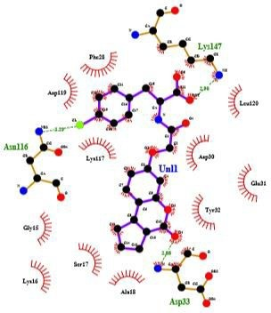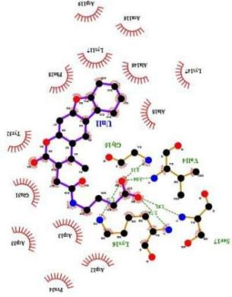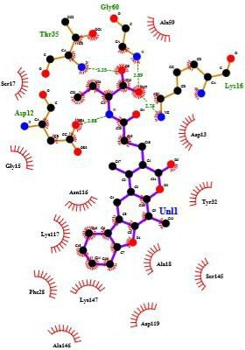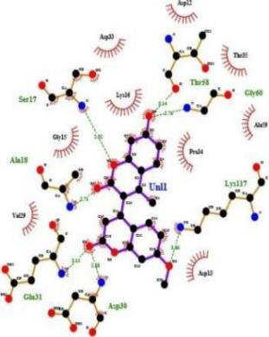
(ZINC02107288) (ZINC02096813) (ZINC02096815) (ZINC02114326)

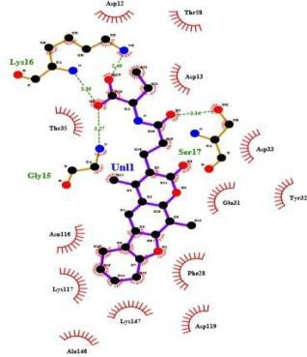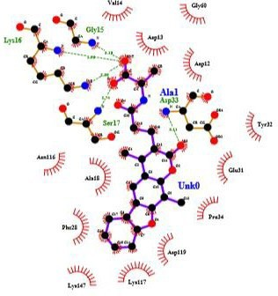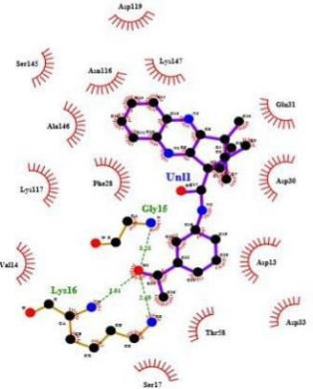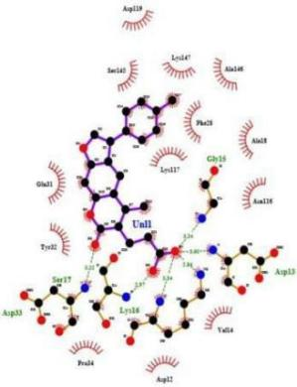
(ZINC01020381) (ZINC06167356) (ZINC02120343) (ZINC02102162)

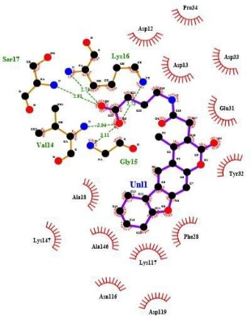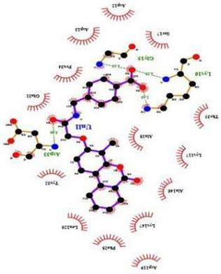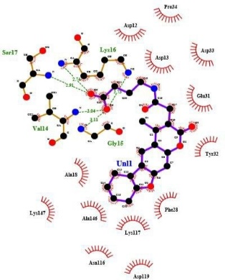
(ZINC02114643) (ZINC00518885) (ZINC03882094)

Figure 2. Comparative 2D representations of protein-ligand interactions for docked complexes generated using LigPlot+.

Each panel presents a detailed schematic of the non-covalent binding environment for a specific ligand within its target protein structure, with both the ligand and surrounding residues depicted in ball-and-stick format for clarity at atomic resolution shown in figure 2. Hydrogen bonding interactions are marked by dashed green lines linking donor and acceptor atoms, while hydrophobic contacts are highlighted by spoked red arcs oriented toward the ligand, illustrating side-chain proximity and surface complementarity. This standardized visualization enables straightforward comparison of key contacts including hydrogen bonds and hydrophobic interactions among different ligand binding poses and mutant protein variants, providing insight into structural determinants of binding affinity. The ability of LigPlot+ to display multiple ligand-protein pairs in parallel aids the interpretation of structure-activity relationships and binding mode selectivity by overlaying or aligning interaction networks. This visual summary highlights critical residues, hydrogen-bond patterns, and hydrophobic contacts that govern ligand recognition, making LigPlot+ diagrams valuable for drug discovery, mutational analysis, and rational design efforts. The atomic-level clarity and automatic annotation of interactions accelerate the evaluation of protein-ligand complexes and enable rapid dissemination of binding site features in publications and reports.

4. DISCUSSION

The present study provides structural and docking-based insights into mutant NRAS, one of the key oncogenic drivers in melanoma. Model validation confirmed that the generated G12D, G13D and Q61R structures were stereo chemically reliable, allowing virtual screening of more than 5,000 natural compounds. Among the top-ranking candidates, three appeared particularly promising, displaying strong binding affinities and stable interactions involving both conserved and mutant residues. Our analysis highlights the importance of conserved residues such as Tyr-32, Thr-35, Phe-28 and Asp-119, which are known to stabilize switch I/II regions and coordinate nucleotide binding. The observation that these residues consistently contributed to ligand stabilization agrees with prior crystal and biochemical studies on RAS proteins. Importantly, the results also suggest that mutant residues introduced at positions 12 and 13 can directly establish novel ligand interactions, particularly through hydrogen bonding, thereby providing unique opportunities for inhibitor design not available in the wild-type context. This dual engagement of conserved stabilizers and mutation-induced pockets may form a rational design principle for NRAS inhibition. NRAS mutations have long been associated with melanoma progression, yet direct pharmacological inhibition of NRAS remains a major therapeutic challenge. Conventional efforts have focused on downstream effectors (MEK, ERK) or membrane localization pathways. Our results suggest that natural compounds, with diverse scaffolds and biocompatibility, may offer new chemical starting points to directly target NRAS itself. This approach is significant given the scarcity of direct NRAS inhibitors in preclinical or clinical pipelines. Nonetheless, the findings presented here are limited by their computational nature. Docking captures only a static snapshot of protein–ligand interactions and does not fully address conformational flexibility, solvation or entropic contributions. Experimental validation, such as binding assays, cellular viability studies in NRAS-mutant melanoma models and structural techniques, will be essential to confirm the predicted inhibitor potential. In addition, molecular dynamics simulations with free energy analyses (e.g., MM-PBSA or MM-GBSA) could refine the stability and ranking of these candidate molecules. Overall, this study demonstrates how integrating protein modeling, structural validation and virtual screening of natural compound libraries can provide insights into potential inhibitors of mutant NRAS. The three prioritized compounds identified here warrant further testing and may serve as lead scaffolds for designing more selective inhibitors. This work underscores the value of computational drug discovery in opening new avenues against difficult-to-target oncogenes such as NRAS in melanoma.

4.CONCLUSION

Virtual screening enabled the identification of natural compounds with selective inhibitory potential against mutant NRAS variants. Key interactions were observed at both conserved and mutation-specific residues, supporting the structural relevance of the predicted binding modes. Three compounds (ZINC02096813, ZINC02120343, ZINC00518885) displayed the most favorable binding characteristics and consistent stability, indicating their promise as lead molecules for further optimization. These results underscore the value of virtual screening in guiding the discovery of candidate inhibitors for oncogenic NRAS in melanoma.

Acknowledgements

The authors gratefully acknowledge Dr. Rohan Meshram from Savitribai Phule Pune University for his invaluable guidance and support throughout the study.

Conflict of Interest

The authors declare that they have no conflicts of interest.

Table 1. "Docking results of top-ranking ZINC compounds (binding free energy ≤ –10 kcal/mol), highlighting predicted hydrogen bond donor–acceptor pairs and residues involved in hydrophobic or van der Waals interactions with the protein active site."

Figure 1. Structural validation and quality assessment for the modeled protein. (A) Protein topology diagram showing secondary structure elements and residue connectivity. (B) Cartoon representation of the 3D protein fold, colored by secondary structure type. (C) Overall model quality plot indicating global model Z-scores; the blue area reflects reference values for well-resolved structures. (D) Local quality assessment plot showing per-residue score fluctuations, highlighting regions of potential structural uncertainty. (E) Ramachandran plot presenting backbone dihedral angle distributions, with most residues occupying favored regions. (F) Summary of model statistics including counts of residues in favored, allowed, and disallowed regions per Ramachandran analysis, along with non-glycine/proline and end-residue counts, indicating high overall stereochemical quality of the model.

Figure 2. Comparative 2D representations of protein-ligand interactions for docked complexes, generated using LigPlot+.

REFERENCES

Al Mahi, A., & Ablain, J. (2022). RAS pathway regulation in melanoma. Disease Models & Mechanisms, 15(2), dmm049229. https://doi.org/10.1242/dmm.049229

Ardito, C. M., Grüner, B. M., Takeuchi, K. K., Lubeseder-Martellato, C., Teichmann, N., Mazur, P. K., DelGiorno, K. E., Carpenter, E. S., Halbrook, C. J., Hall, J. C., et al. (2012). EGF receptor is required for KRAS-induced pancreatic tumorigenesis. Cancer Cell, 22(3), 304–317. https://doi.org/10.1016/j.ccr.2012.07.024

Cancer.Net Editorial Board. (2025a). Melanoma: Stages. American Society of Clinical Oncology. https://www.cancer.net/cancer-types/melanoma/stages
(accessed 21 September 2025)

Cancer.Net Editorial Board. (2025b). Melanoma: Statistics. American Society of Clinical Oncology. https://www.cancer.net/cancer-types/melanoma/statistics
(accessed 21 September 2025)

Cherfils, J., & Zeghouf, M. (2013). Regulation of small GTPases by GEFs, GAPs, and GDIs. Physiological Reviews, 93(1), 269–309. https://doi.org/10.1152/physrev.00003.2012

Cox, A. D., Fesik, S. W., Kimmelman, A. C., Luo, J., & Der, C. J. (2014). Drugging the undruggable RAS: Mission possible? Nature Reviews Drug Discovery, 13, 828–851.

FAF-Drugs4. (2025). ADME/Tox filtering. Université Paris-Diderot. http://fafdrugs4.mti.univ-paris-diderot.fr/
(accessed 21 September 2025)

Harvey, A. L., Edrada-Ebel, R., & Quinn, R. J. (2015). The re-emergence of natural products for drug discovery in the genomics era. Nature Reviews Drug Discovery, 14, 111–129.

Howe, L. R., Leevers, S. J., Gómez, N., Nakielny, S., Cohen, P., & Marshall, C. J. (1992). Activation of the MAP kinase pathway by the protein kinase Raf. Cell, 71(2), 335–342. https://doi.org/10.1016/0092-8674(92)90362-3

Hu, Z., & Martí, J. (2025). Atomic-level mechanisms of abnormal activation in NRAS oncogenes from two-dimensional free energy landscapes. Nanoscale, 17. https://doi.org/10.1039/D4NR03372H

Johnson, C. W., Reid, D., Parker, J. A., Harrison, R. A., Weston, L., Peti, W., … Campbell, S. L. (2017). The small GTPases K-Ras, N-Ras, and H-Ras have distinct biochemical properties determined by allosteric effects. Journal of Biological Chemistry, 292(31), 12981–12993. https://doi.org/10.1074/jbc.M117.778886

Johnson, D. B., & Puzanov, I. (2015). Treatment of NRAS-mutant melanoma. Current Treatment Options in Oncology, 16(4), 15. https://doi.org/10.1007/s11864-015-0330-z

Kanehisa, M., & Goto, S. (2000). KEGG: Kyoto encyclopedia of genes and genomes. Nucleic Acids Research, 28(1), 27–30. https://doi.org/10.1093/nar/28.1.27

Kitchen, D. B., Decornez, H., Furr, J. R., & Bajorath, J. (2004). Docking and scoring in virtual screening for drug discovery. Nature Reviews Drug Discovery, 3(11), 935–949.

Kolch, W., Berta, D., & Rosta, E. (2023). [Title]. Biochemical Journal, 480, 1–23. https://doi.org/10.1042/BCJ20220547

Li, G., & Zhang, X. C. (2004). GTP hydrolysis mechanism of Ras-like GTPases. Journal of Molecular Biology, 340(5), 921–932. https://doi.org/10.1016/j.jmb.2004.05.079

Li, S., Balmain, A., & Counter, C. M. (2018). A model for RAS mutation patterns in cancers: Finding the sweet spot. Nature Reviews Cancer, 18(12), 767–777. https://doi.org/10.1038/s41568-018-0076-6

LigPlus. (2025). Automatic generation of ligand–protein interaction diagrams. European Bioinformatics Institute. https://www.ebi.ac.uk/thornton-srv/software/LigPlus/
(accessed 21 September 2025)

Lionta, E., Spyrou, G., Vassilatis, D. K., & Cournia, Z. (2014). Structure-based virtual screening for drug discovery: Principles, applications and recent advances. Current Topics in Medicinal Chemistry, 14(16), 1923–1938.

McCormick, F. (2015). KRAS as a therapeutic target. Clinical Cancer Research, 21, 1797–1801.

Moore, A. R., Rosenberg, S. C., McCormick, F., & Malek, S. (2020). RAS-targeted therapies: Is the undruggable drugged? Nature Reviews Drug Discovery, 19(8), 533–552. https://doi.org/10.1038/s41573-020-0068-6

National Cancer Institute. (2025). The cancer genome atlas (TCGA) – Melanoma skin cancer. https://www.cancer.gov/about-nci/organization/ccg/research/structural-genomics/tcga/studied-cancers/melanoma-skin
(accessed 21 September 2025)

Navas, C., Hernández-Porras, I., Schuhmacher, A. J., Sibilia, M., Guerra, C., & Barbacid, M. (2012). EGF receptor signaling is essential for K-Ras oncogene-driven pancreatic ductal adenocarcinoma. Cancer Cell, 22(3), 318–330.

Newman, D. J., & Cragg, G. M. (2020). Natural products as sources of new drugs. Journal of Natural Products, 83(3), 770–803.

Normanno, N., Tejpar, S., Morgillo, F., De Luca, A., Van Cutsem, E., & Ciardiello, F. (2009). Implications for KRAS status and EGFR-targeted therapies in metastatic colorectal cancer. Nature Reviews Clinical Oncology, 6(9), 519–527.

Ostrem, J. M., & Shokat, K. M. (2016). Direct small-molecule inhibitors of KRAS: From structural insights to mechanism-based design. Nature Reviews Drug Discovery, 15(11), 771–785.

PROCHECK. (2025). Stereochemical quality assessment of protein structures. European Bioinformatics Institute. (accessed 21 September 2025)

ProSA. (2025). Protein structure analysis. (accessed 21 September 2025)

Pylayeva-Gupta, Y., Grabocka, E., & Bar-Sagi, D. (2011). RAS oncogenes: Weaving a tumorigenic web. Nature Reviews Cancer, 11(11), 761–774.

Radhakrishnan, S., Menon, P., & Silva, K. (2024). Python Prescription (PyRx) transforms virtual drug discovery with AI-driven tools. African Journal of Biomedical Research, 27(3s).

Rodriguez-Viciana, P., Warne, P. H., Dhand, R., Vanhaesebroeck, B., Gout, I., Fry, M. J., Waterfield, M. D., & Downward, J. (1994). Phosphatidylinositol-3-OH kinase as a direct target of Ras. Nature, 370(6490), 527–532.

Spoerner, M., Hozsa, C., Poetzl, J. A., Reiss, K., Ganser, P., Geyer, M., & Kalbitzer, H. R. (2010). Conformational states of human rat sarcoma (Ras) protein complexed with its natural ligand GTP. Journal of Biological Chemistry, 285(51), 39768–39778.

Vetter, I. R., & Wittinghofer, A. (2001). The guanine nucleotide-binding switch in three dimensions. Science, 294(5545), 1299–1304.

Wellbrock, C., & Arozarena, I. (2016). The complexity of the ERK/MAP-kinase pathway and the treatment of melanoma skin cancer. Frontiers in Cell and Developmental Biology, 4, 33.

Wood, K. W., Sarnecki, C., Roberts, T. M., & Blenis, J. (1992). Ras mediates nerve growth factor receptor modulation of three signal-transducing kinases. Cell, 68(6), 1041–1050.

ZINC Database. (2025). Ligand discovery and virtual screening. https://zinc.docking.org/
(accessed 21 September 2025)

